Lab 3 Group: Alpha Patrick Cook Lucas Anesti Nicholas Hersey

Simulated RISC_CPU Diagram

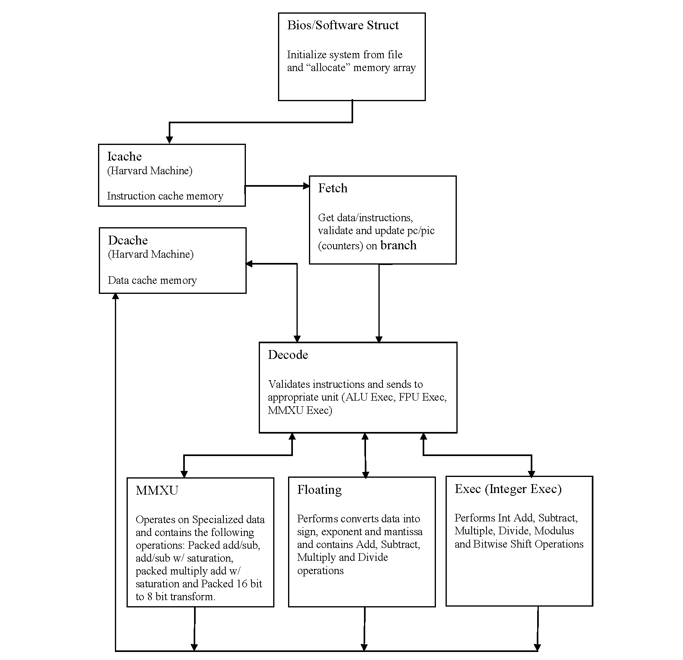

Bios Struct

Initializes “system” from external file and allocates an array size of 4000. Checks that the array does not overflow. Uses a stall to wait for data to be read/write.

Dcache Struct

Used as the data memory, indicating the machine is based on a Harvard machine, initialized from file. The memory size is set to 4000. Includes read/write operations.

Icache Struct

Used to store the instructions in memory, indicating the machine is based on a Harvard machine, sets maxsize to 64 bit system using hexadecimal. Includes read/write operations.

Fetch Struct

The Fetch Struct contains the functions to get the ram data, branch address, next program counter address, stall/interrupt, branch prediction fetch (pre-fetch), ram read/write, program counter update and validate instructions.

Decode Struct

The Decode Struct validates valid instructions and uses switch statements for the following instructions:

case 0x0: // halt
case 0x01: // add R1, R2, R3
case 0x02: // addi R1, R2, #value
case 0x03: // addc R1, R2, R3 + Carrybit
case 0x04: // sub R1, R2, R3
case 0x05: // subi R1, R2, #value
case 0x06: // subc R1, R2, R3 - Carrybit
case 0x07: // mul R1, R2, R3
case 0x08: // div R1, R2, R3
case 0x09: // nand R1, R2, R3
case 0x0a: // and R1, R2, R3
case 0x0b: // or R1, R2, R3
case 0x0c: // xor R1, R2, R3
case 0x0d: // NOT R1, R2
case 0x0e: // modulo R1 = R2 mod R3
case 0x4d: // lw R1, R2, offset
case 0x4e: // sw R1, R2, offset
case 0x0f: // mov R1, R2
case 0x10: // beq R1, R2, label
case 0x11: // bne R1, R2, label
case 0x12: // bgt R1, R2, label
case 0x13: // bge R1, R2, label
case 0x14: // blt R1, R2, label
case 0x16: // j label
case 0x17: // jal label for procedure call
case 0x18: // jr
case 0x29: // fadd R1, R2, R3
case 0x2a: // fsub R1, R2, R3
case 0x2b: // fmul R1, R2, R3
case 0x2c: // fdiv R1, R2, R3
case 0x31: // mmxadd R1, R2, R3
case 0x32: // mmxadds R1, R2, R3
case 0x33: // mmxsub R1, R2, R3
case 0x34: // mmxsubs R1, R2, R3
case 0x35: // pmadd R1, R2, R3
case 0x36: // pack R1, R2, R3
case 0x37: // mmxck R1, R2, R3 MMX Chroma Keying
case 0xe0: // flush register
case 0xf0: // ldpid process_number
case 0xff: // QUIT
default : // Invalid Operator code

Execute Struct

The Execute Struct receives data and instructions and uses a switch statement to carry out the correct process. The following processes are available through the switch statement:

case 1: // add with carry
case 2: // sub with carry
case 3: // add without carry
case 4: // sub without carry
case 5: // multiply assume 2 clock cycle multiplication
case 6: // divide assume 2 clock cycle multiplication
case 7: // bitwise NAND
case 8: // bitwise AND
case 9: // bitwise OR
case 10: // bitwise XOR
case 11: // bitwise complement
case 12: // left shift
case 13: // right shift
case 14: // modulo
default: // bad code received

Floating Struct (FPU)

The Floating Struct act as the floating point processor unit. It converts the data to data using the sign, exponent and mantissa. It uses a switch statement to add, subtract, multiply and divide floating point number.

MMXU Struct

The mmxu struct contains the opcode, operand A, operand B, destination register, validation and output. It is intended to speed up performance of certain applications. The following processes are available through switch statements:

case 0: // Stall
case 3: // add
case 4: // add with saturation
case 5: // sub
case 6: // sub with saturation
case 7: // packed multiply add with saturation
// a3*b3+a2*b2 , a1*b1+a0*b0
case 8: // packed b1 (16bit) b0(16bit) and a1(16 bit) a0(16 bit)
// to B1(8bit) B0(8bit) A1(8bit) A0(8bit)
case 9: // mmx chroma keying
default: Invalid operation

Paging Struct

The paging struct routes the data, addresses and instructions between the different available architecture units.

